Heartworms

What are Heartworms?
Canine heartworm disease develops when a dog is bitten by a mosquito carrying microscopic heartworm larvae (juvenile worms) of a parasite called Dirofilaria Immitis. As a mosquito feeds, these microscopic larvae are deposited on the dog and quickly penetrate the skin to begin their migration into the dog’s bloodstream. Adult heartworms can grow 10-12 inches in length and make their home in the right side of the heart and pulmonary (lung) arteries, often causing lung disease and heart failure.
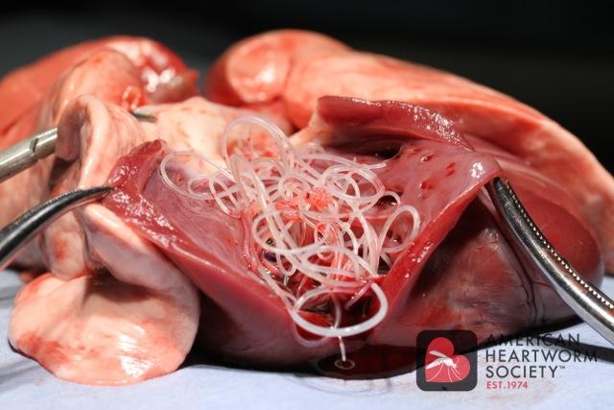
Detecting Heartworm Infections
There are many blood tests that can be used to detect a heartworm infection in dogs. No diagnostic test is 100%, and infections cannot consistently be detected until the heartworms are 7 months old, and multiple female heartworms are present. Additional diagnostics including radiographs, ultrasounds, or repeated blood tests may also be recommended.

When should testing be done?
For Mount Vernon Animal Hospital, our recommendation is to test our patients a minimum of every 2 years, starting at 2 years of age. Some patients may be recommended to get more frequent testing. We would also recommend testing if your pet has been off prevention for more than 6 months.

What about Treatment?
Without treatment, heartworm disease will worsen and can lead to more serious quality of life issues. Treatment does not come without risks though, as dead parasites may cause further injury to the lungs and pulmonary arteries. A thorough workup may need to be done on your pet prior to treatment, to assess level of risk for the treatment. This could include but is not limited to; a physical exam, blood and urine tests, and radiographs or ultrasounds.

Preventing Heartworm
Heartworm Preventatives are highly effective when given properly and on a timely schedule. It is important to note that these medications are quickly eliminated from a dog’s body shortly after given and do not continue to protect dogs from future infection. Instead they eliminate infections acquired since the last dose. All approved heartworm preventatives are: highly effective, safe, easy to use, relatively inexpensive, and the one MVAH carries also provides additional protection against many intestinal parasites. Preventative is ALWAYS safer and more affordable than treating a dog with an adult heartworm infection. Please remember, the best way to eliminate the risk of a heartworm infection is to keep your dog on YEAR-ROUND preventative.

